

NOTARY SERVICE AND BONDING AGENCY, INC.
550 Hulet Drive
Suite 105
Bloomfield Hills, MI 48302

Web: NotaryBonding.com Toll Free: 1-800-366-8279 Email: info@notarybonding.com Fax: 1-800-637-5992

Michigan New or Renewal Notary Bond Packages | Economy Package “A” | Standard Package “B” | Deluxe Package “C” | Elite Package “D” | Superior Package “E”
Michigan Package Pricing | $ 24.00 | $ 43.00 | $ 63.00 | $ 83.00 | $ 123.00
$ 10,000 Notary Public 6-7 Year Bond | X | X | X | X | X
Toll Free Telephone Support For Full 6-7 Year Term | X | X | X | X | X
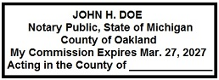  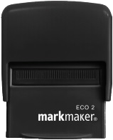  Self-Inking Commission Expiration Date Stamp |  | X | X | X | X
$ 10,000 Notary E&O 6-7 Year Policy | X | X
$ 20,000 Notary E&O 6-7 Year Policy |  |  | X
$ 30,000 Notary E&O 6-7 Year Policy |  |  |  | X
$ 50,000 Notary E&O 6-7 Year Policy |  |  |  |  | X
SELECT A NOTARY BOND PACKAGE MICHIGAN EXPRESS NOTARY BOND SERVICE
$ 24.00 Economy Package “A” $ 15.00 Receive your notary bond via email in 1 business day.

$ 43.00 Standard Package “B”

$ 63.00 Deluxe Package “C”

$ 83.00 Elite Package “D”

$ 123.00 Superior Package “E”
SELECT A SHIPPING METHOD
$ 5.95 Standard Shipping (Not Trackable)

*Provide yourself with end-to-end product trackable shipping. FedEx and UPS options are only for stamps and/or embossers. All other products will be shipped standard mail. Allow 1 to 3 business days for manufacturing and personalization.
$ 15.95 FedEx Ground (*Trackable)

$ 19.95 FedEx 3 Day (*Trackable)

$ 24.95 FedEx 2 Day (*Trackable)

$ 36.95 UPS Next Day (*Trackable)
COMPLETE MANDATORY INFORMATION

Commission name as it will appear on the documents you notarize: ______________________________________________________________________

Date of Birth: Month: _____ Day: _____ Year: _____ Email: ________________________________________ Phone: _____________________________

New Notary Renewal Notary - Commission Expiration Date: Month: ________________ Day: ________________ Year: _______________

Residential Address: _______________________________________________ Residential City: ___________________________________________________
Residential State: ____________ Residential Zip Code: _________________ Residential County: ________________________________________________
Ship To Address: __________________________________________________ City: ____________________________ State: ______ Zip Code: ____________

*Non-Resident’s of Michigan Provide Business Name & Address:
*Business Name: __________________________________________________ *Business Address: ________________________________________________
*Business City: ___________________________________*Business State: _____ *Business Zip Code: __________ *Business County: _________________
SELECT A PAYMENT METHOD
Charge by Visa, MasterCard, American Express or Discover: Check or Money Order enclosed:

Make payable to Notary Service and Bonding Agency, Inc.
CC Number: Provide Check or Money Order number: _____________________

Expiration Date (MM/YY): CCV:

Cardholder Name: ______________________________________________________
Signature of Cardholder: X ______________________________________________ TOTAL AMOUNT: $____________________

WWW.NOTARYBONDING.COM/STORE/MICHIGAN Page 1 of 3 - Michigan 02/2021

OFFICIAL NOTARY PUBLIC RECORDING JOURNALS
Image | Description | Journal Entries | Code | Price | Quantity | Product Total
 | White  Soft Cover | 140 Entries | #999 | $ 11.00 | X ___________ | $ ___________
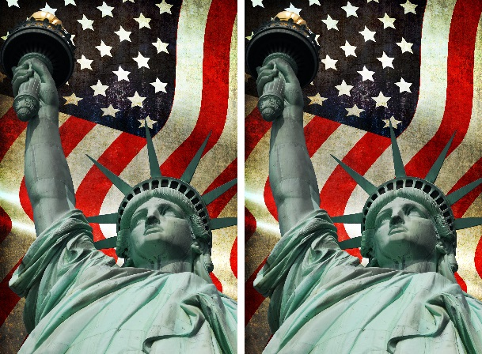 | Statue of Liberty  Soft Cover | 140 Entries | #303-A | $ 14.00 | X ___________ | $ ___________
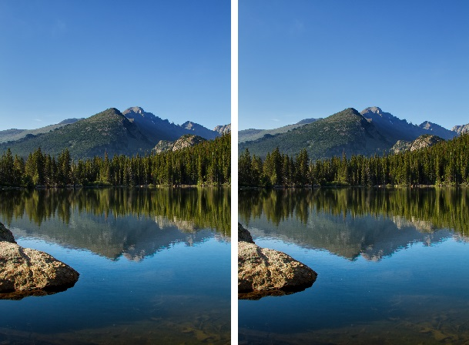 | Rocky Mountains  Soft Cover | 140 Entries | #303-B | $ 14.00 | X ___________ | $ ___________
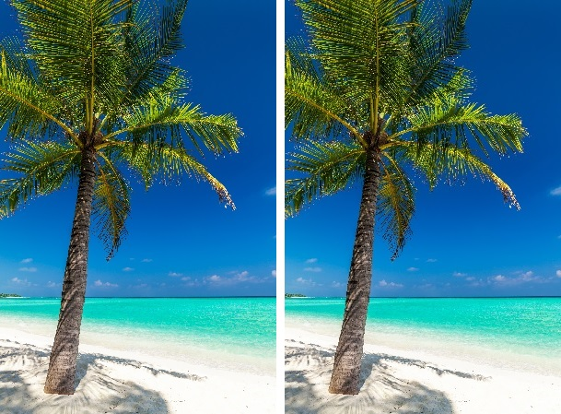 | Tropical Beach  Soft Cover | 140 Entries | #303-C | $ 14.00 | X ___________ | $ ___________
 | Pink  Soft Cover | 284 Entries | #304-B | $ 18.00 | X ___________ | $ ___________
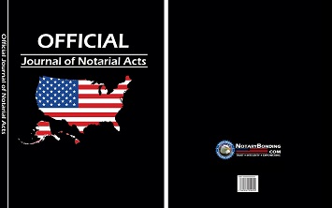 | Black  Hard Cover | 400 Entries | #304-C | $ 30.00 | X ___________ | $ ___________

COMMISSION EXPIRATION DATE STAMPS
Image | Description | Impressions | Code | Price | Quantity | Product Total
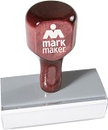 | MarkMaker  Rubber | Requires  Stamp Pad | #204-A | $ 16.95 | X ___________ | $ ___________
 | MarkMaker  Self-Inking | 5,000 | #205-A | $ 19.95 | X ___________ | $ ___________
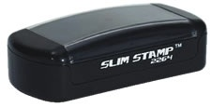 | Slim Pocket  Pre-Inked | 15,000 | #207-A | $ 22.95 | X ___________ | $ ___________
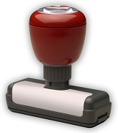 | MarkMaker  Pre-Inked | 25,000 | #206-A | $ 24.95 | X ___________ | $ ___________
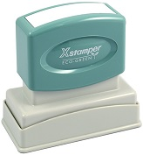 | Xstamper  Pre-Inked | 50,000 | #206-1S | $ 30.95 | X ___________ | $ ___________

COMMISSION EXPIRATION DATE STAMPS WITH SEAL
Image | Description | Impressions | Code | Price | Quantity | Product Total
 | MarkMaker  Rubber | Requires  Stamp Pad | #204 | $ 16.95 | X ___________ | $ ___________
 | MarkMaker  Self-Inking | 5,000 | #205 | $ 19.95 | X ___________ | $ ___________
 | MarkMaker  Pre-Inked | 25,000 | #206 | $ 24.95 | X ___________ | $ ___________

SEAL STAMPS
Image | Description | Impressions | Code | Price | Quantity | Product Total
 | MarkMaker  Rubber | Requires  Stamp Pad | #204-RR | $ 18.95 | X ___________ | $ ___________
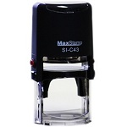 | MaxStamp  Self-Inking | 5,000 | #205-RSI | $ 21.95 | X ___________ | $ ___________
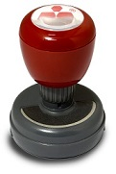 | MarkMaker  Pre-Inked | 25,000 | #206-RPI | $ 27.95 | X ___________ | $ ___________
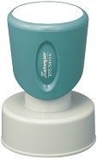 | Xstamper  Pre-Inked | 50,000 | #206-RS | $ 35.95 | X ___________ | $ ___________

SEAL EMBOSSERS
Image | Description | Type | Code | Price | Quantity | Product Total
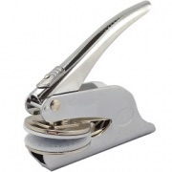 | Chrome | Hand Held | #200 | $ 22.00 | X ___________ | $ ___________
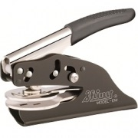 | Shiny Model  Solid Steel | Hand Held | #198-S | $ 31.00 | X ___________ | $ ___________
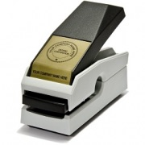 | MarkMaker  Black Matte | Desk Top | #201 | $ 29.00 | X ___________ | $ ___________
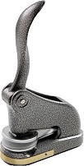 | Pebble Grey | Desk Top | #199 | $ 34.00 | X ___________ | $ ___________
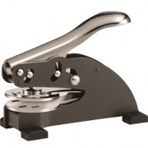 | Shiny Model  Solid Steel | Desk Top | #197-S | $ 36.00 | X ___________ | $ ___________

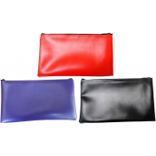
NOTARY SUPPLIES

Image | Description | Size | Impressions | Set | Code | Price | Quantity | Product Total
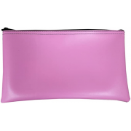 | Leatherette  Zippered  Supply Pouch | 11’’ L x 7’’ W  11’’ L x 7’’ W  11’’ L x 7’’ W | N/A | N/A | #230 / Red  #230 / Blue  #230 / Black | $ 11.95  $ 11.95  $ 11.95 | X ___________  X ___________  X ___________ | $ ___________  $ ___________  $ ___________
 | Pink Leatherette Zippered  Supply Pouch | 11’’ L x 7’’ W | N/A | N/A | #231 | $ 11.95 | X ___________ | $ ___________
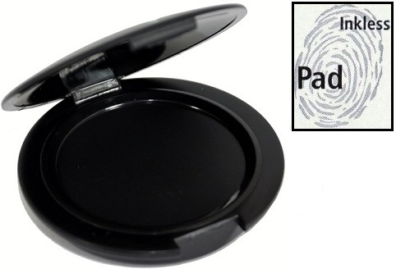 | Inkless  Fingerprint  Pad | N/A | 1,000 | N/A | #720 | $ 8.95 | X ___________ | $ ___________
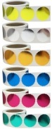 | Embosser  Foil Starburst  Seals | 2’’ L x 2’’ W  2’’ L x 2’’ W  2’’ L x 2’’ W  2’’ L x 2’’ W  2’’ L x 2’’ W  2’’ L x 2’’ W | N/A | Set of 50  Set of 50  Set of 50  Set of 50  Set of 50  Set of 50 | #203-A / Gold  #203-A / Silver  #203-A / Bronze  #203-A / Blue  #203-A / Rose  #203-A / Green | $ 7.00  $ 7.00  $ 7.00  $ 7.00  $ 7.00  $ 7.00 | X ___________  X ___________  X ___________  X ___________  X ___________  X ___________ | $ ___________  $ ___________  $ ___________  $ ___________  $ ___________  $ ___________
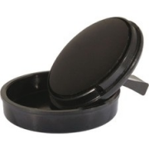 | Embosser  Standard  Inker | N/A | 2,500 | N/A | #202-B | $ 13.00 | X ___________ | $ ___________
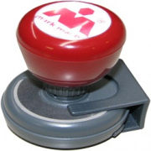 | Embosser  Deluxe  Inker | N/A | 20,000 | N/A | #202-A | $ 18.00 | X ___________ | $ ___________

